Curriculum vitae

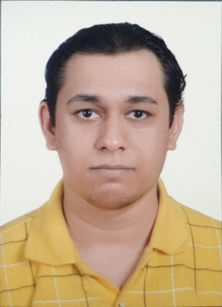**Personal Information:**

**Name**: Hassan Ali Habib Jasim

**Date** **of Birth**: 22/7/1995

**Nationality:** Bahraini

**Telephone**: 37116898

**Email:** [HassanAliHabib.7@hotmail.com](mailto:HassanAliHabib.7@hotmail.com)

**Address**: House 2368 – Road 2256 – Block 1022 Dumistan

**Education:**

Graduated at Shaikh Isa Bin Ali Secondary School

**Languages:**

Arabic (reading , writing , speaking)

English (reading , writing , speaking)